Diagonal of a Face
# Source: AI Source: Provided by: [Data Path: Persons Table -> ID Column: 1, Name_En Column: Motasem Essam] -> From: [ChatGPT] on [7/25/2026]
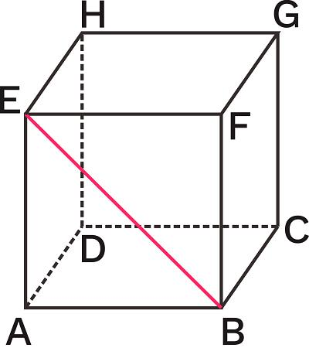
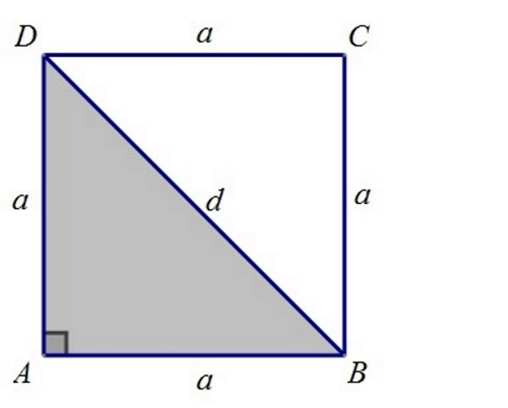
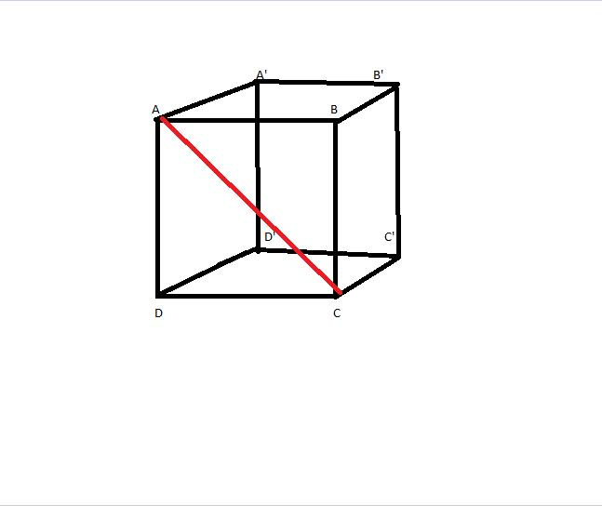

Definition
# Source: AI Source: Provided by: [Data Path: Persons Table -> ID Column: 1, Name_En Column: Motasem Essam] -> From: [ChatGPT] on [7/25/2026]
A diagonal of a face is a line segment joining two non-adjacent vertices of the same face of a three-dimensional solid.
The segment lies entirely within that face and connects opposite vertices without following the face's edges.
For example, a square face of a cube has two diagonals, each connecting one pair of opposite corners. These diagonals cross at the center of the square.

Simple Definition
# Source: AI Source: Provided by: [Data Path: Persons Table -> ID Column: 1, Name_En Column: Motasem Essam] -> From: [ChatGPT] on [7/25/2026]
A face diagonal is a straight segment drawn across one face of a solid, from one corner of that face to its opposite corner.
Examples:
- A diagonal across a square face of a cube.
- A diagonal across a rectangular face of a cuboid.
- A diagonal across a rectangular side of a prism.
Important distinction: A face diagonal lies within a single face. A space diagonal joins vertices through the interior of the solid and does not lie entirely in one face.

Key Characteristics
# Source: AI Source: Provided by: [Data Path: Persons Table -> ID Column: 1, Name_En Column: Motasem Essam] -> From: [ChatGPT] on [7/25/2026]
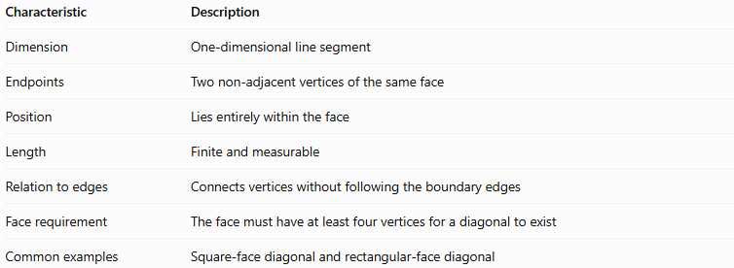
Characteristic | Description
Dimension | One-dimensional line segment
Endpoints | Two non-adjacent vertices of the same face
Position | Lies entirely within the face
Length | Finite and measurable
Relation to edges | Connects vertices without following the boundary edges
Face requirement | The face must have at least four vertices for a diagonal to exist
Common examples | Square-face diagonal and rectangular-face diagonal
A triangular face has no face diagonals because every pair of its vertices is already connected by an edge.

5. Types of Face Diagonals

A. Diagonal of a square face
# Source: AI Source: Provided by: [Data Path: Persons Table -> ID Column: 1, Name_En Column: Motasem Essam] -> From: [ChatGPT] on [7/25/2026]
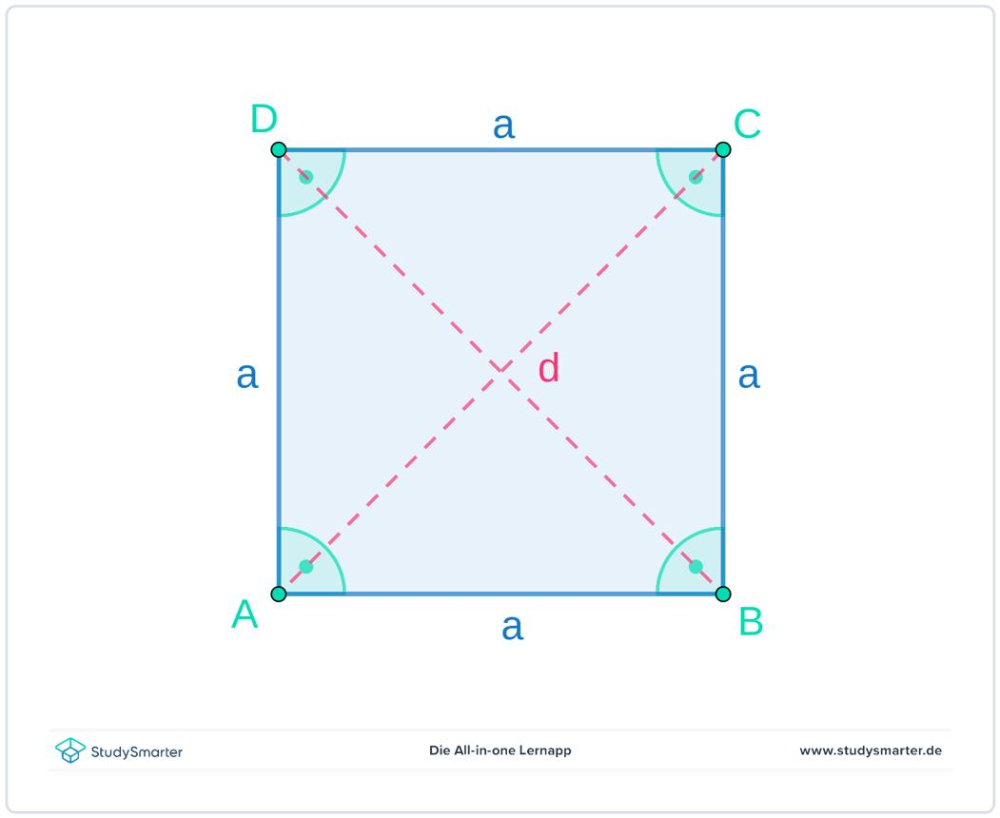
A square has four vertices and two diagonals. Both diagonals have the same length and bisect each other at right angles.
If the side length is $a$, the diagonal length is
$$\boxed{d=a\sqrt{2}}$$
This follows from the Pythagorean theorem:
$$d^{2}=a^{2}+a^{2}=2a^{2}$$
Therefore, $d=a\sqrt{2}$.

B. Diagonal of a rectangular face
# Source: AI Source: Provided by: [Data Path: Persons Table -> ID Column: 1, Name_En Column: Motasem Essam] -> From: [ChatGPT] on [7/25/2026]
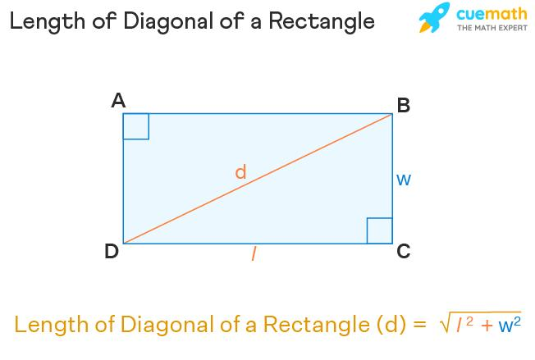
A rectangle has two equal diagonals. If its length is $l$ and width is $w$, then
$$\boxed{d=\sqrt{l^{2}+w^{2}}}$$
For example, if $l=6\text{ cm}$ and $w=8\text{ cm}$,
$$d=\sqrt{6^{2}+8^{2}}=\sqrt{100}$$
$$\boxed{d=10\text{ cm}}$$

C. Diagonal of a parallelogram face
# Source: AI Source: Provided by: [Data Path: Persons Table -> ID Column: 1, Name_En Column: Motasem Essam] -> From: [ChatGPT] on [7/25/2026]
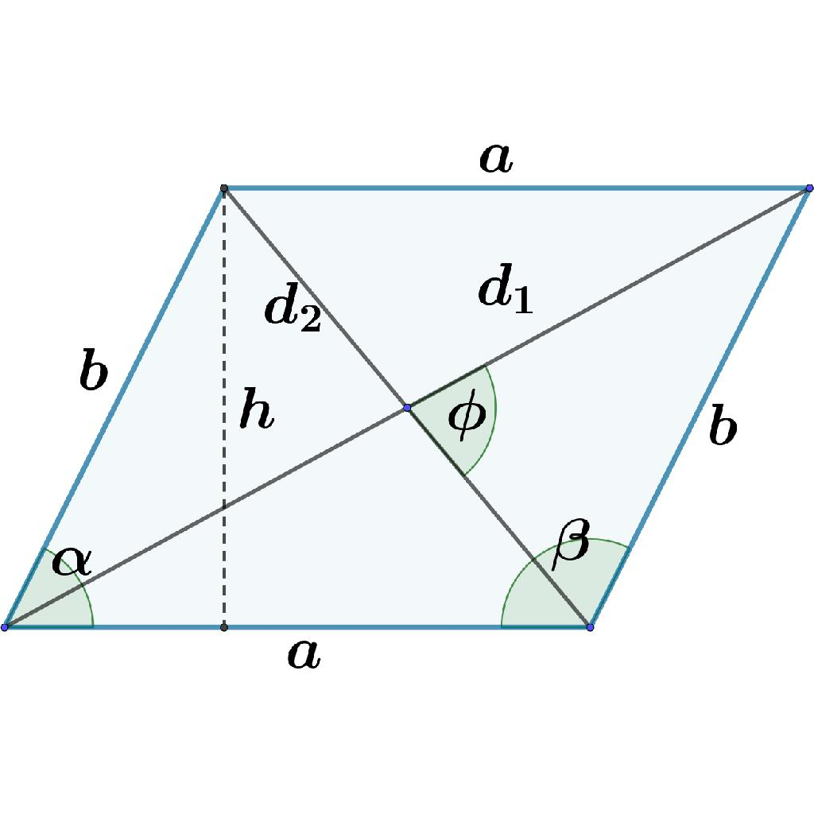
A parallelogram has two diagonals that generally have different lengths. If its adjacent side lengths are $a$ and $b$, and the included angle is $θ$, the diagonal lengths are
$$\boxed{d_{1}=\sqrt{a^{2}+b^{2}+2ab\cos{θ}}}$$
$$\boxed{d_{2}=\sqrt{a^{2}+b^{2}-2ab\cos{θ}}}$$
The two diagonals are equal when the parallelogram is a rectangle, including a square.

D. Diagonal of a general polygonal face
# Source: AI Source: Provided by: [Data Path: Persons Table -> ID Column: 1, Name_En Column: Motasem Essam] -> From: [ChatGPT] on [7/25/2026]
A polygonal face with $n$ vertices has
$$\boxed{\frac{n\left(n-3\right)}{2}}$$
diagonals, counting each diagonal once.
For example, a pentagonal face has
$$\frac{5\left(5-3\right)}{2}=5$$
diagonals.
The formula counts diagonals within the polygon, not edges or diagonals passing through the solid.

Face Diagonals in Common Solids
# Source: AI Source: Provided by: [Data Path: Persons Table -> ID Column: 1, Name_En Column: Motasem Essam] -> From: [ChatGPT] on [7/25/2026]
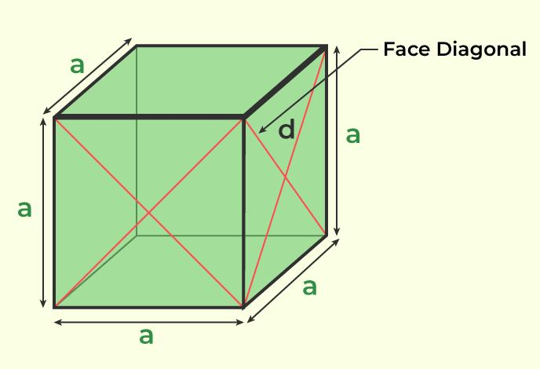
Cube
Each of its six square faces has two diagonals.
- Faces: 6
- Diagonals per face: 2
- Total face diagonals: 12
- Length of each: $a\sqrt{2}$
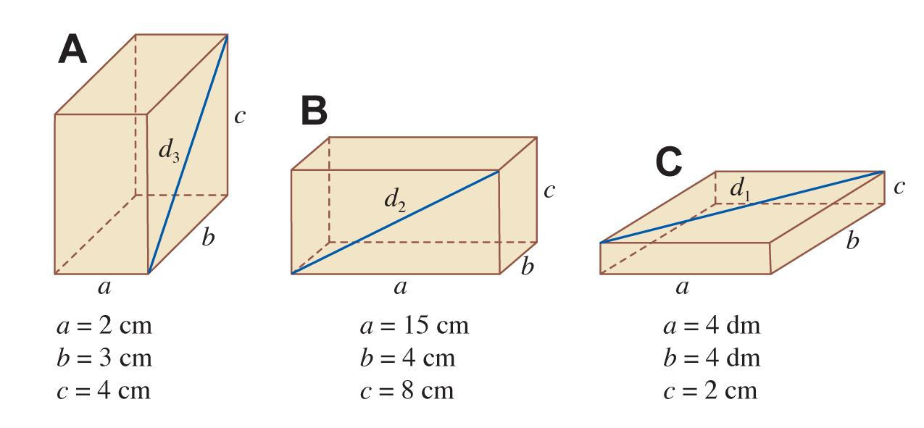
Rectangular prism (cuboid)
It has three pairs of opposite rectangular faces.
- Four diagonals of length $\sqrt{l^{2}+w^{2}}$
- Four of length $\sqrt{l^{2}+h^{2}}$
- Four of length $\sqrt{w^{2}+h^{2}}$
These account for 12 face diagonals in total.
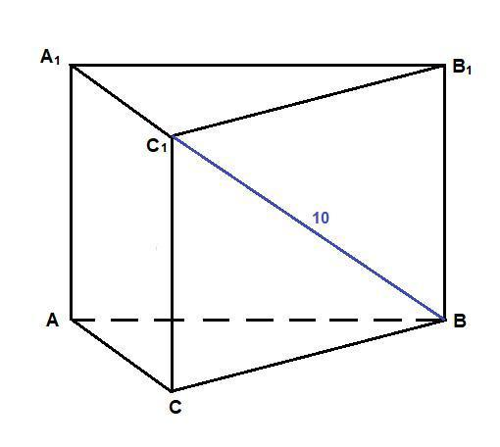
Triangular prism
Its two triangular faces have no diagonals, but each of its three rectangular lateral faces has two.
- Rectangular faces: 3
- Total face diagonals: 6
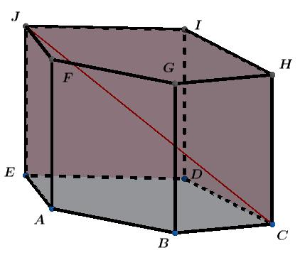
Pentagonal prism
Each pentagonal base has five diagonals. Each rectangular lateral face has two.
- Base diagonals: $2×5=10$
- Lateral face diagonals: $5×2=10$
- Total face diagonals: 20

Calculating a Face Diagonal Using Coordinates
# Source: AI Source: Provided by: [Data Path: Persons Table -> ID Column: 1, Name_En Column: Motasem Essam] -> From: [ChatGPT] on [7/25/2026]
If two opposite vertices of a face have coordinates
$$A=\left(x_{1},y_{1},z_{1}\right), B=\left(x_{2},y_{2},z_{2}\right)$$
the diagonal length is the three-dimensional distance between them:
$$\boxed{d=\sqrt{{\left(x_{2}-x_{1}\right)}^{2}+{\left(y_{2}-y_{1}\right)}^{2}+{\left(z_{2}-z_{1}\right)}^{2}}}$$
Because both endpoints belong to the same face, the segment remains within that face.

Worked Example 1: Square face of a cube
# Source: AI Source: Provided by: [Data Path: Persons Table -> ID Column: 1, Name_En Column: Motasem Essam] -> From: [ChatGPT] on [7/25/2026]
Suppose a cube has side length $5\text{ cm}$.
The diagonal of one square face is
$$d=a\sqrt{2}$$
$$d=5\sqrt{2}$$
$$\boxed{d≈7.07\text{ cm}}$$

Worked Example 2: Rectangular face of a cuboid
# Source: AI Source: Provided by: [Data Path: Persons Table -> ID Column: 1, Name_En Column: Motasem Essam] -> From: [ChatGPT] on [7/25/2026]
Suppose a cuboid has dimensions
$$l=9\text{ cm}, w=12\text{ cm}, h=4\text{ cm}$$
The diagonal of its length-width face is
$$d=\sqrt{l^{2}+w^{2}}$$
$$d=\sqrt{9^{2}+{12}^{2}}=\sqrt{225}$$
$$\boxed{d=15\text{ cm}}$$
The diagonal of a length-height face is
$$d=\sqrt{9^{2}+4^{2}}=\sqrt{97}≈9.85\text{ cm}$$
The face diagonal depends on which face is selected.

Face Diagonal vs. Edge vs. Space Diagonal
# Source: AI Source: Provided by: [Data Path: Persons Table -> ID Column: 1, Name_En Column: Motasem Essam] -> From: [ChatGPT] on [7/25/2026]
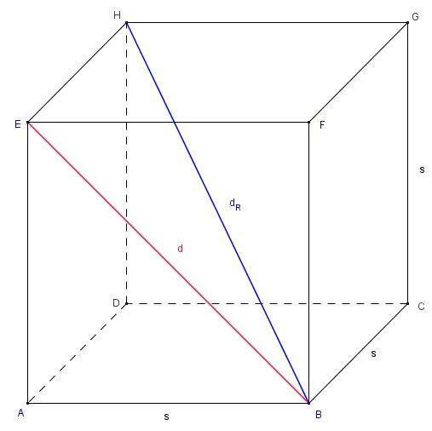
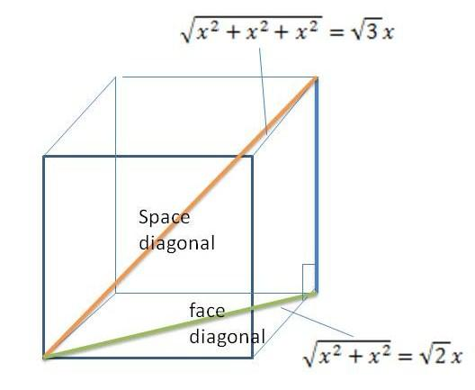
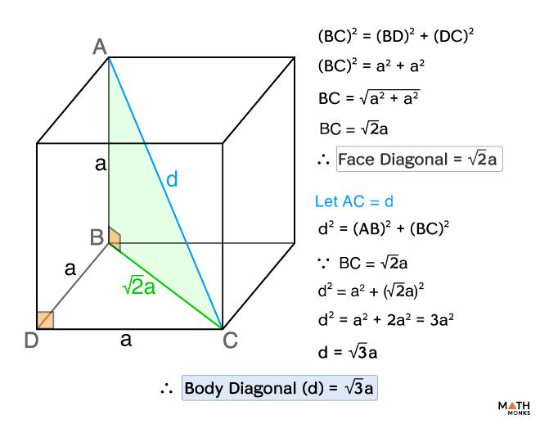
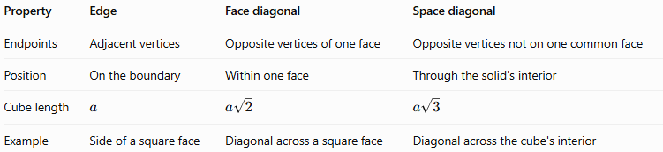
Property | Edge | Face diagonal | Space diagonal
Endpoints | Adjacent vertices | Opposite vertices of one face | Opposite vertices not on one common face
Position | On the boundary | Within one face | Through the solid's interior
Cube length | $$a$$ | $$a\sqrt{2}$$ | $$a\sqrt{3}$$
Example | Side of a square face | Diagonal across a square face | Diagonal across the cube's interior
For a cube, the space diagonal is longer than a face diagonal, which is longer than an edge.
$$a<a\sqrt{2}<a\sqrt{3} \left(a>0\right)$$

Applications of Face Diagonals
# Source: AI Source: Provided by: [Data Path: Persons Table -> ID Column: 1, Name_En Column: Motasem Essam] -> From: [ChatGPT] on [7/25/2026]
Face diagonals are useful in:
- Geometry: Calculating distances between opposite corners of a face.
- Architecture: Measuring diagonals across rectangular panels and surfaces.
- Engineering: Checking the dimensions and squareness of plates and frames.
- 3D modeling: Connecting non-adjacent vertices on a polygonal face.
- Construction: Verifying rectangular layouts by comparing diagonal measurements.

Key Points
# Source: AI Source: Provided by: [Data Path: Persons Table -> ID Column: 1, Name_En Column: Motasem Essam] -> From: [ChatGPT] on [7/25/2026]
- A face diagonal joins two non-adjacent vertices of the same face.
- It lies entirely within that face.
- A triangular face has no diagonals.
- A square face of side $a$ has diagonal $a\sqrt{2}$.
- A rectangular face with dimensions $l$ and $w$ has diagonal $\sqrt{l^{2}+w^{2}}$.
- A cube has 12 face diagonals when diagonals on all six faces are counted.
- A space diagonal passes through the solid and is different from a face diagonal.

Conclusion
# Source: AI Source: Provided by: [Data Path: Persons Table -> ID Column: 1, Name_En Column: Motasem Essam] -> From: [ChatGPT] on [7/25/2026]
A face diagonal is a line segment that connects opposite vertices within a single face of a solid. It extends the study of edges by connecting vertices that are not adjacent and provides a practical way to calculate distances across square, rectangular, and other polygonal faces.

